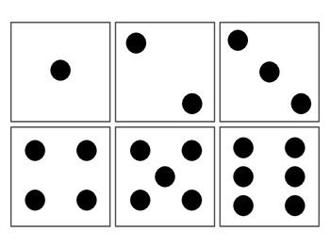
- You can make dice cards to use instead of rolling dice.
- Print and cut these up or draw dot patterns on paper squares.
- Shuffle the cards and pick at random.

